**EXPRESSEATS**

- Food Recipe Recommendation System

**PROJECT REPORT**

**Course**: DATA MINING (CMPE-255)

**Course Instructor**: VIJAY ERANTI

**Project Team:**

Harshith Akkapelli

Neeharika Singh

Sanjay Bhargav Kudupudi

**Github** : <https://github.com/ExpressNesters/ExpressEats.git>

**Colab:** Part1:<https://colab.research.google.com/drive/1xDXfK0uYqlIlknKVtaToKmxSuUHSyhGb?usp=sharing>

Part-2: <https://colab.research.google.com/drive/1i6yGBU2sgiFkLy11uICRgaliG6m-6Jh6?usp=sharing>

Part-3: <https://colab.research.google.com/drive/1WENxYP60Bb-1gnp_w8rDnKdTvaHQu-C0?usp=sharing>

Part-4: <https://colab.research.google.com/drive/1WENxYP60Bb-1gnp_w8rDnKdTvaHQu-C0?usp=sharing>

**Dataset**: <https://www.kaggle.com/datasets/kanishk307/6000-indian-food-recipes-dataset>

Presentation video: <https://drive.google.com/file/d/10XoRLLtFAw1xXVFQzulynYpqbIlnJH2K/view?usp=drive_link>

**Abstract:**

Have you ever been in a dilemma about what to cook with the ingredients you have with limited time? Addressing a common pain point in our daily lives: not knowing what to prepare with limited time and odd supplies in the kitchen. This can be exhausting because we could be spending our time on more important things. We developed a system called "ExpressEats," which recommends personalized recipes depending on the user's time restrictions and available ingredients.

This project's goal is to create a Food meal Recommendation System that gives users individualized meal recommendations based on common ingredients and short preparation times.

This system will combine data science and machine learning approaches to produce a user-friendly application that enhances the cooking experience and assists users in effectively preparing excellent meals.

**Introduction:**

Our objective is to develop a system that, given the total time and translated ingredients, recommends a recipe that is closest to these criteria.

We want to achieve this using the power of data mining and machine learning to build a recipe recommendation system, which take ingredients as the input from the user and utilizes machine learning and recommends the recipes available based on the ingredients provided by the user. By doing so we were able to achieve our objectives.

**Key Features:**

Users can give ingredients as input.  
Users can get the recipe based on the ingredients provided.

**Related Works:**

We came across some related recommendation systems, some of them used different approaches and some of them even used complex approaches.

Although we have many different techniques, we choose the optimal and less complex technical approach. Which differs our work from others.

**Data:**   
We have used a dataset from kaagle which contains data that is required for us to perform and use for our application.

Details of the dataset are below

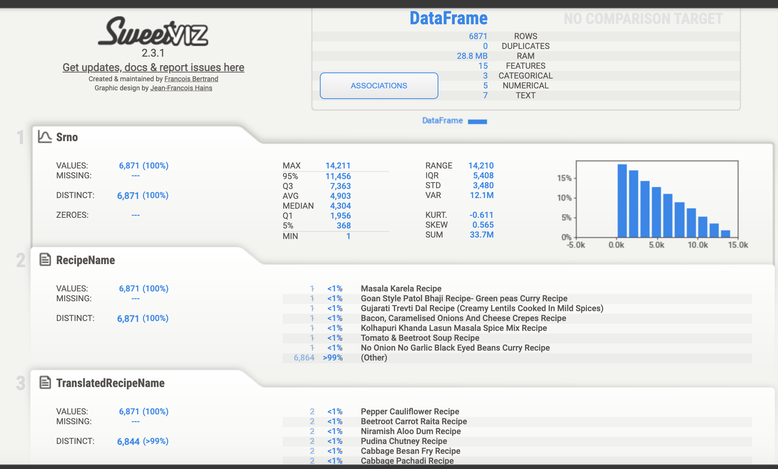

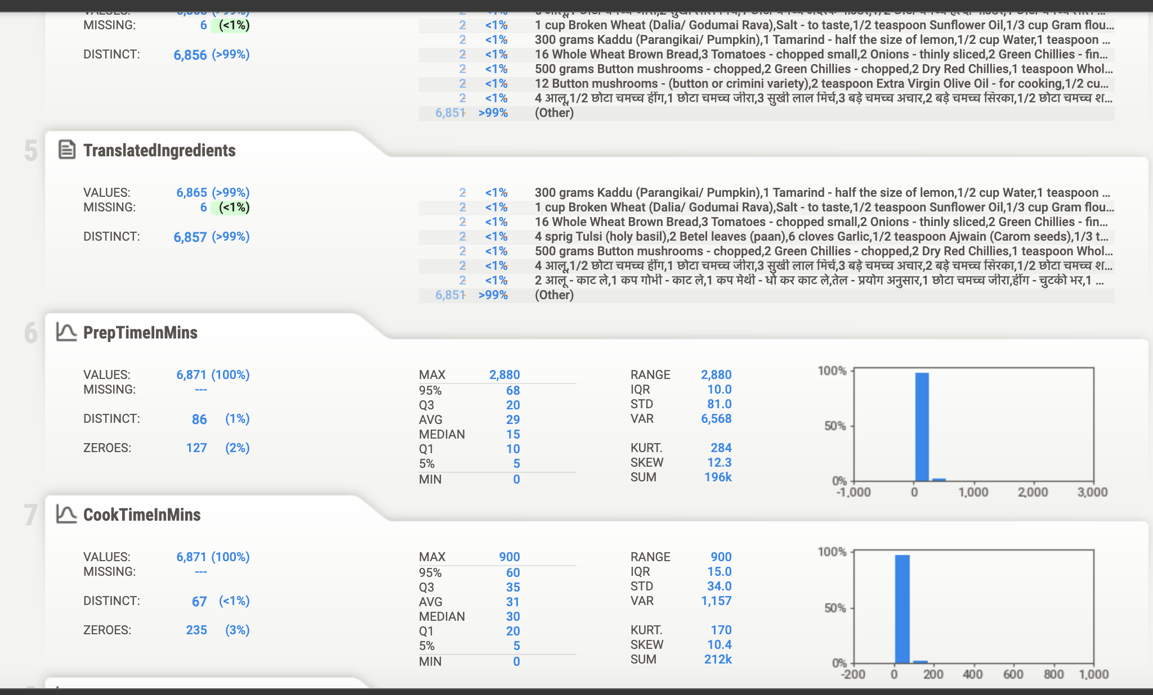

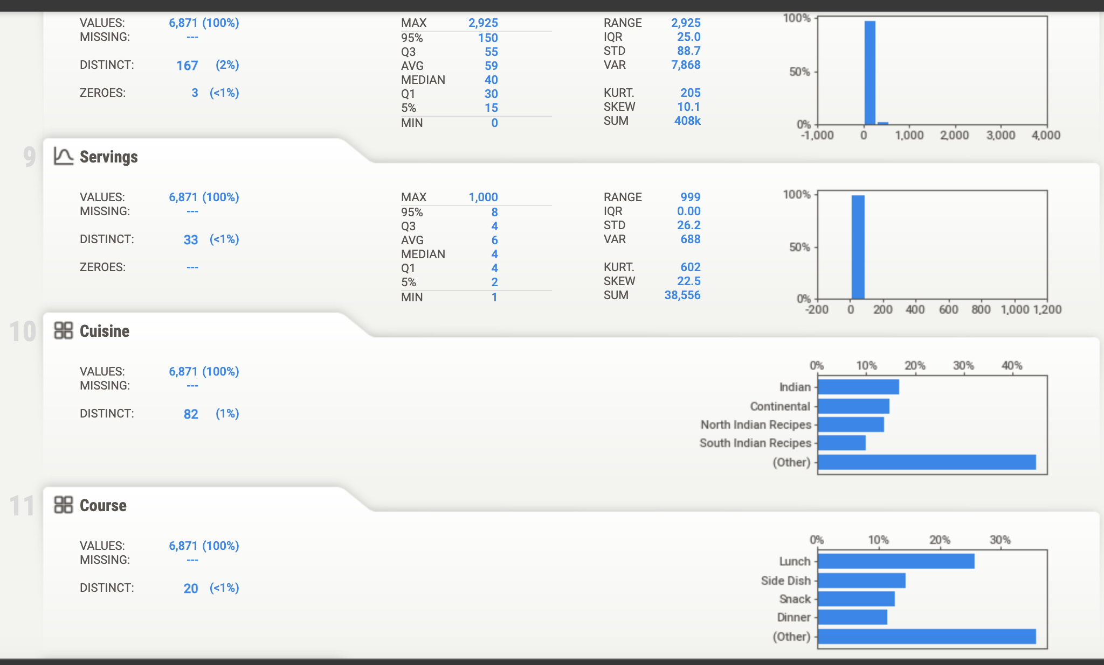

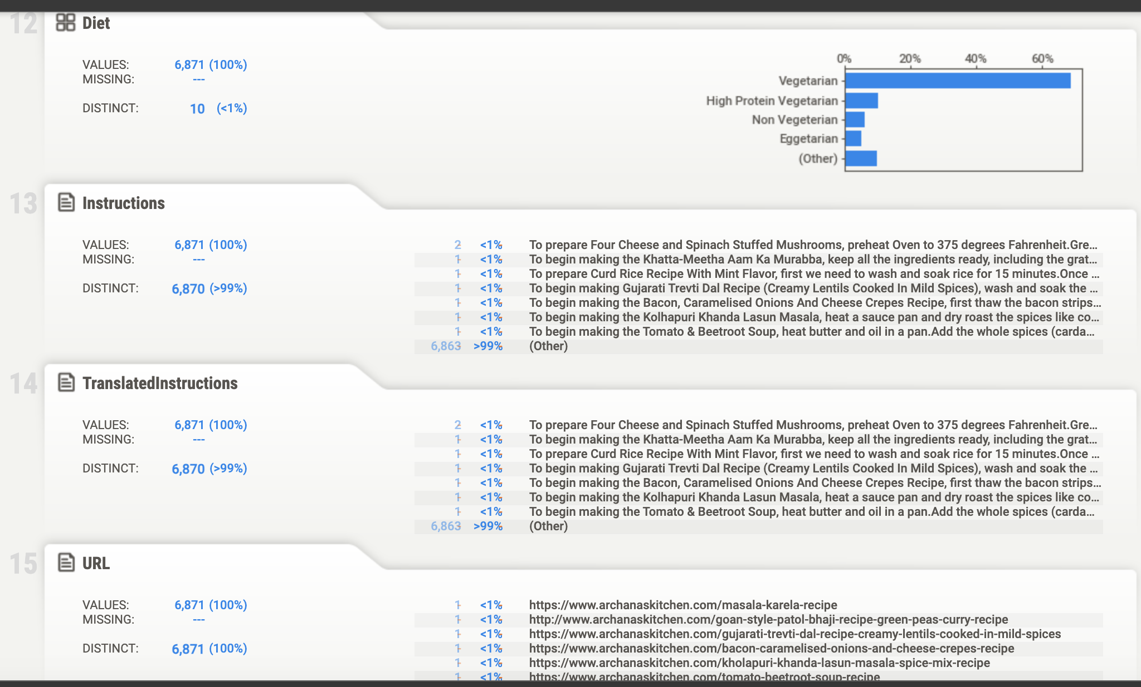

**Methodology:**

We have used CRISP-DM methodology for the recommendation system as it has perfectly fit the requirements for modeling our solution.

**Business Understanding**   
 This can be viewed as a recommendation system problem where the input features are time and ingredients, and the output is a recipe recommendation.

1. **Data Collection:**

We have collected a dataset which includes ingredients and cooking time. This dataset has more than 6000+ recipes in it.

1. **Data Preprocessing:**

This dataset being a vast dataset with more data in it. We have performed data cleaning and preprocessing the data by handling the missing values.

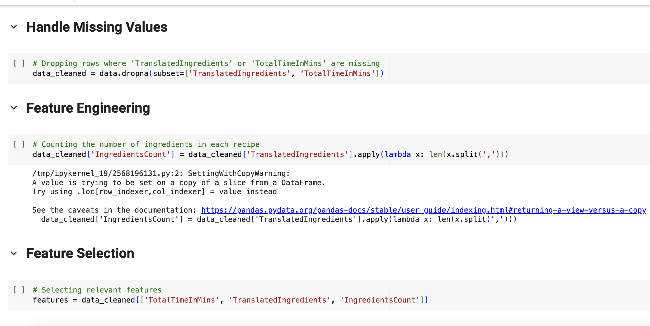

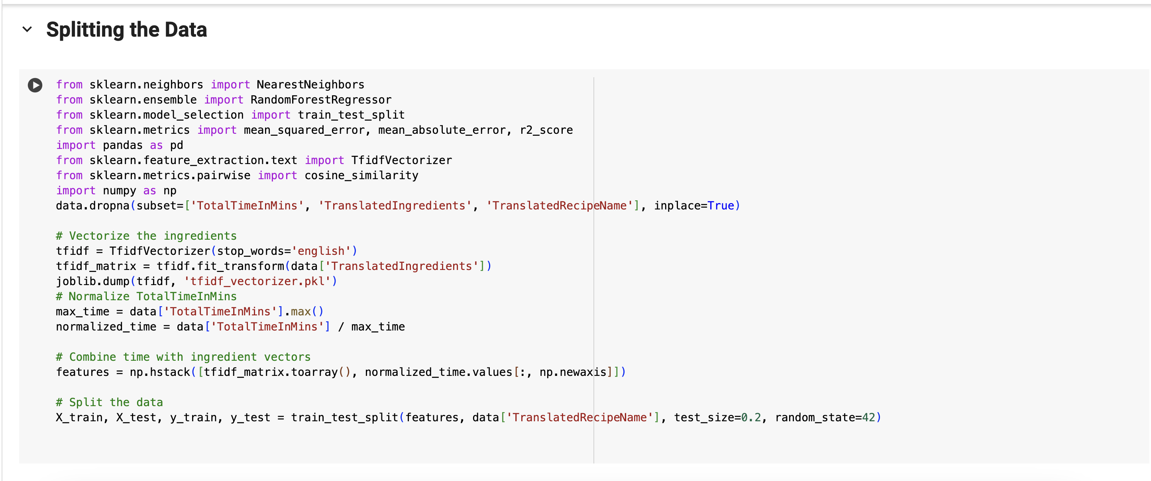

1. **Model Training:**  
   We have trained using different regression models

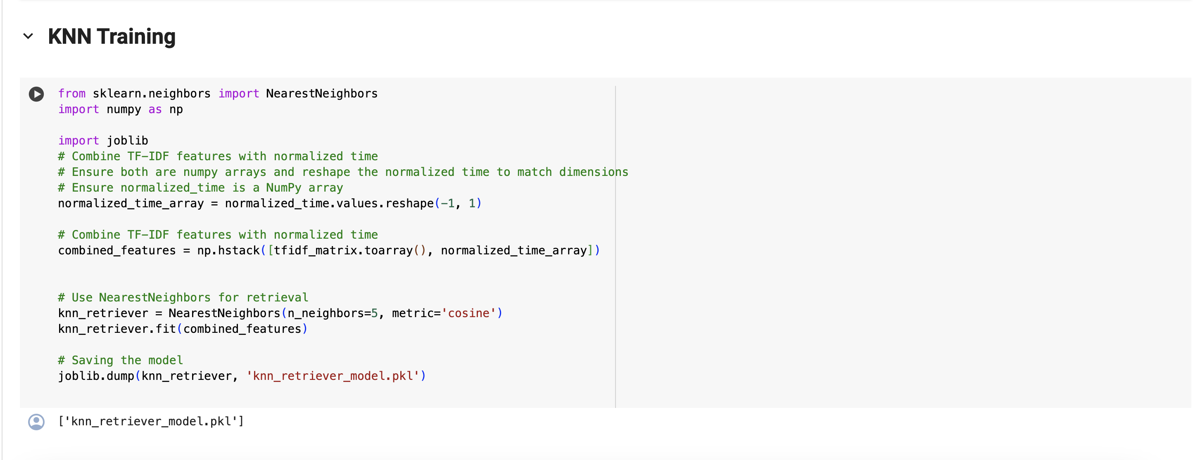

1. **Recommendation Engine:**

Implement collaborative filtering and content-based filtering algorithms.   
 Developed a scoring system to prioritize recipes based on ingredients and preparation time.

1. **User interface:**  
   Created a user-friendly web interface.

The web interface has search bar and recipe recommendation functionalities.

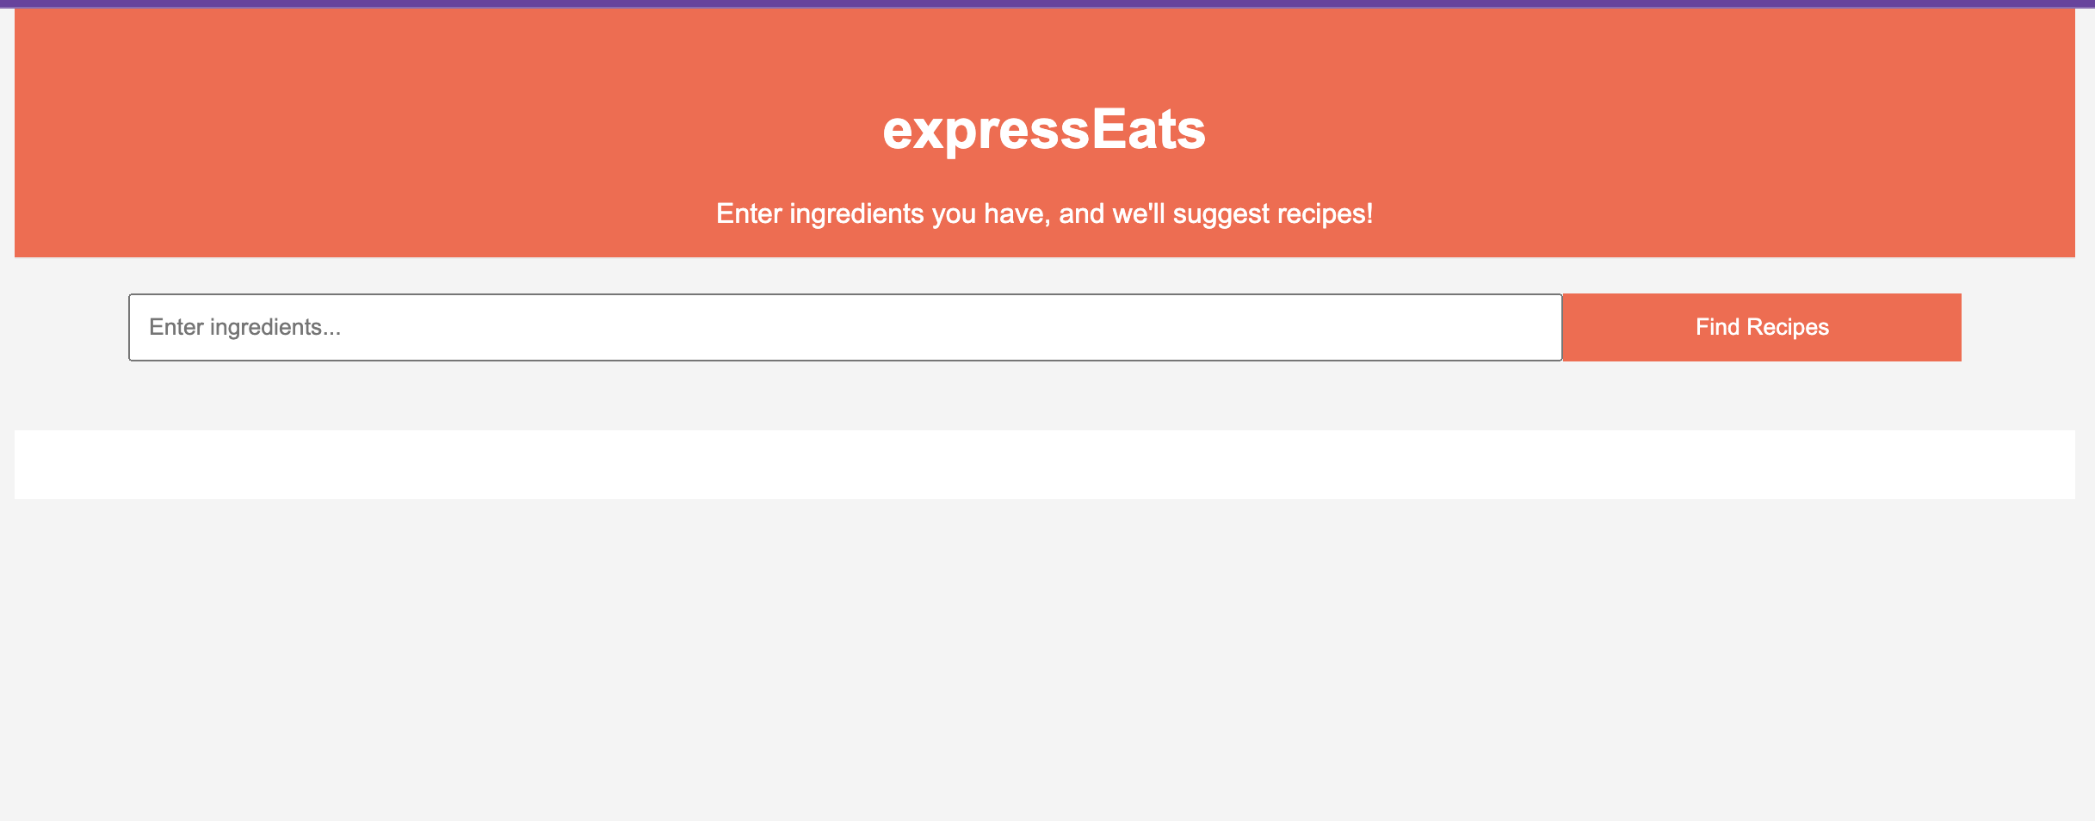

1. **Performance Evaluation:**

We have used various metrics to evaluate model performance.

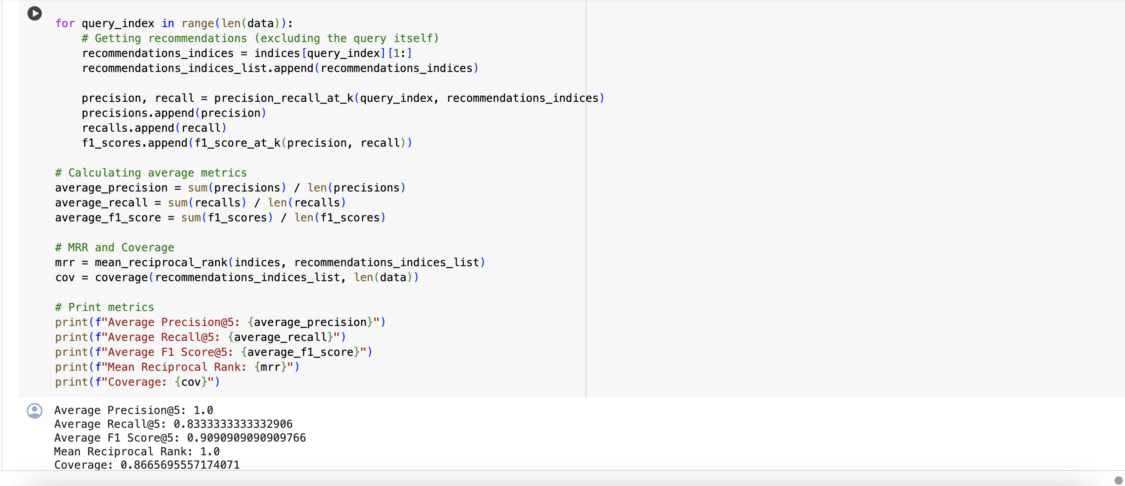

7.  **Deployment:**  
 Deployed the Food Recipe Suggestion System on AWS platform ensuring scalability and reliability.

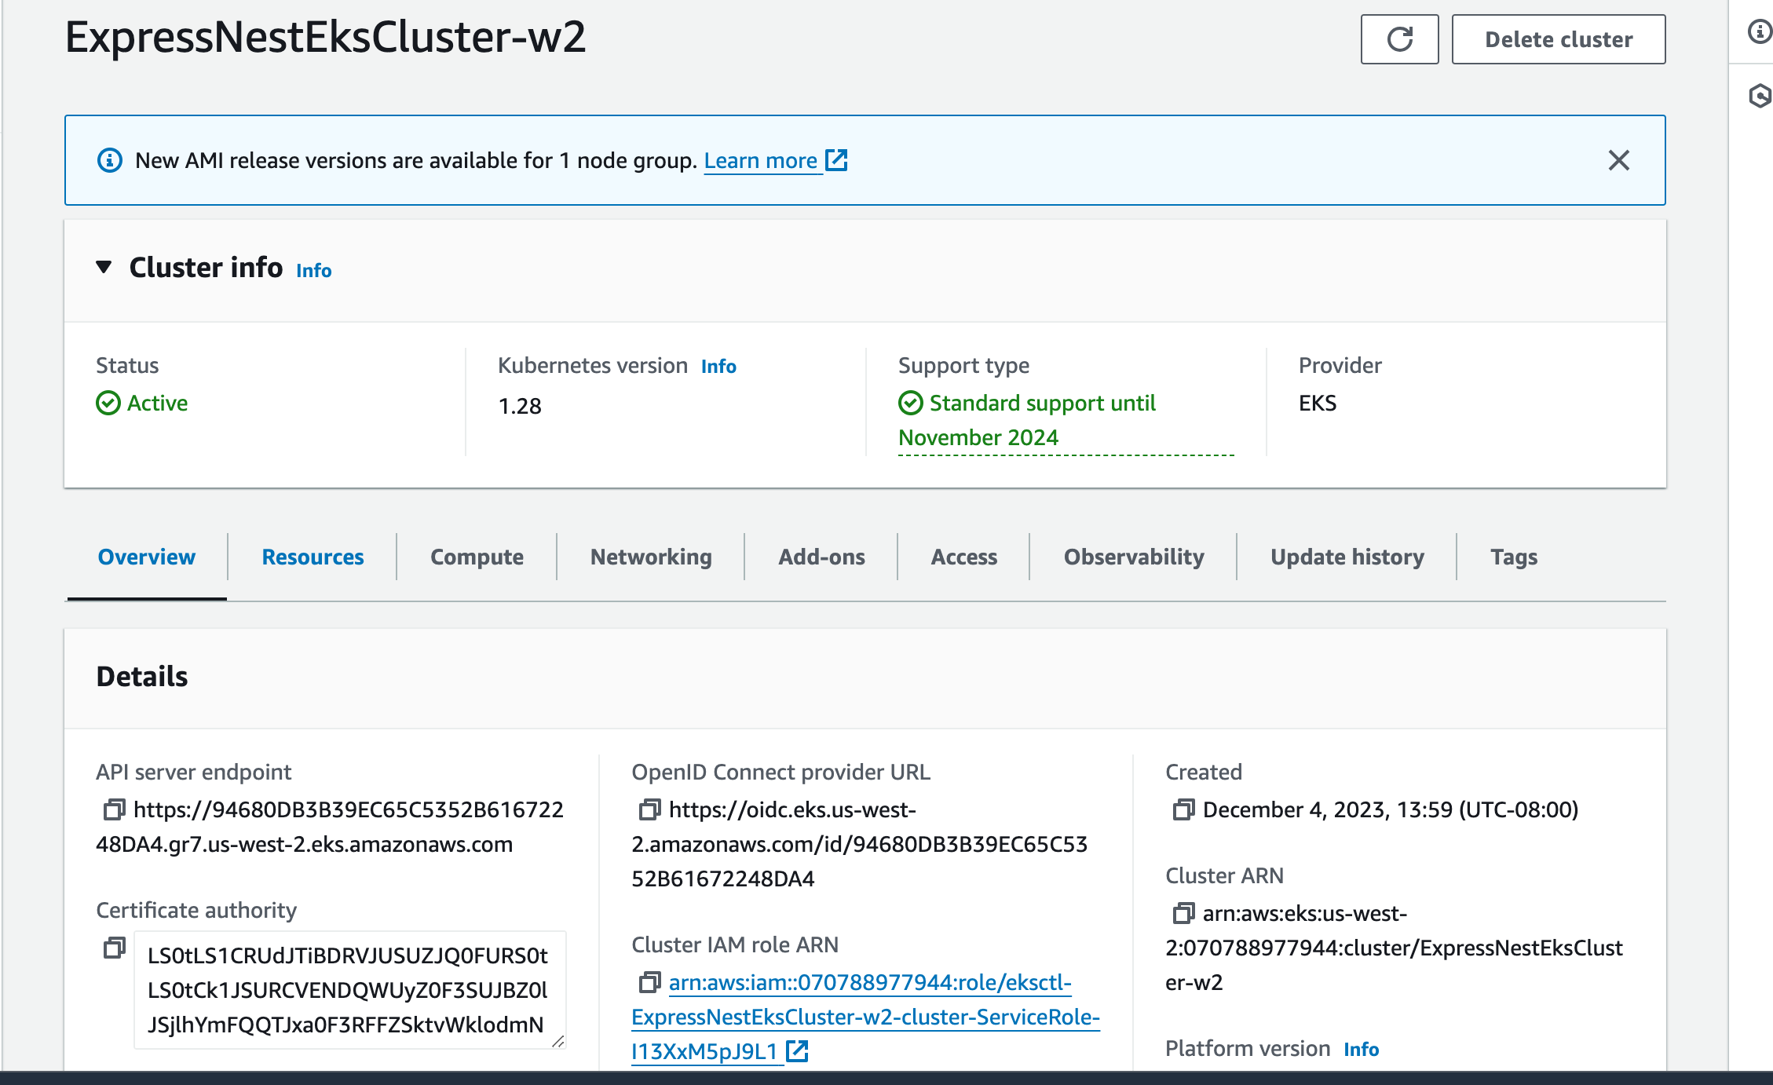

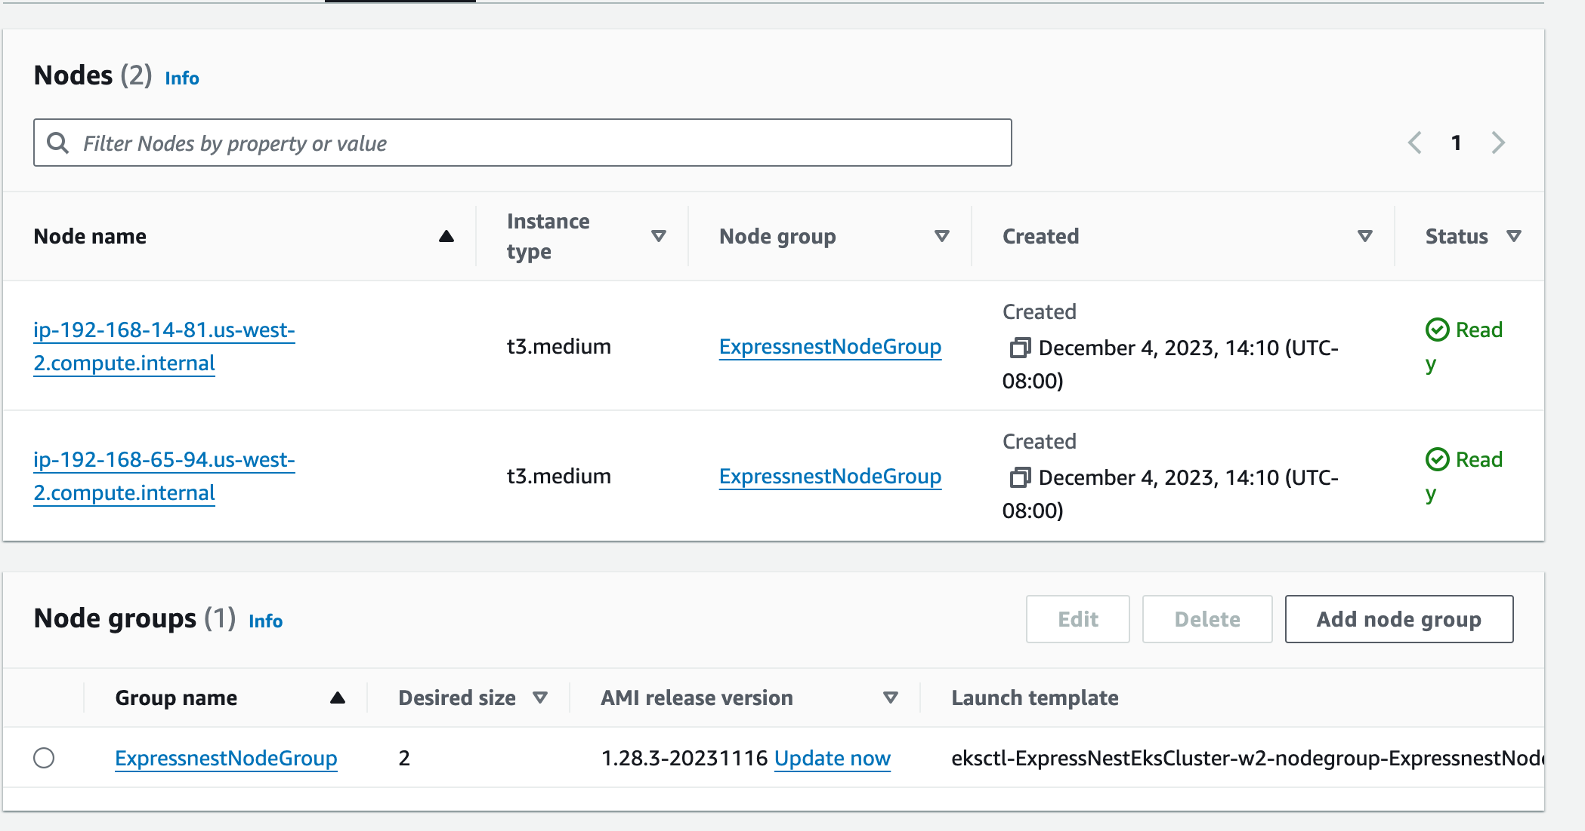

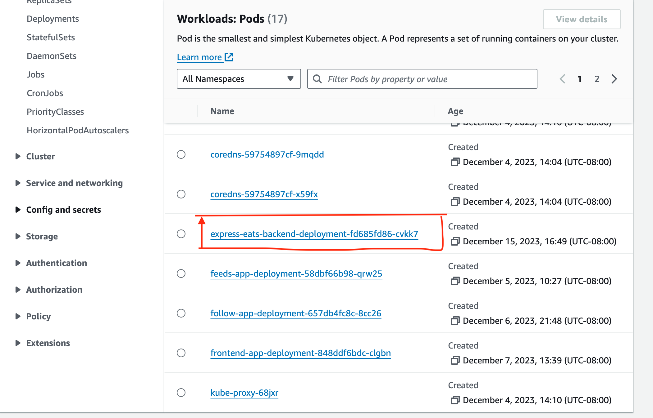

**Architecture:**

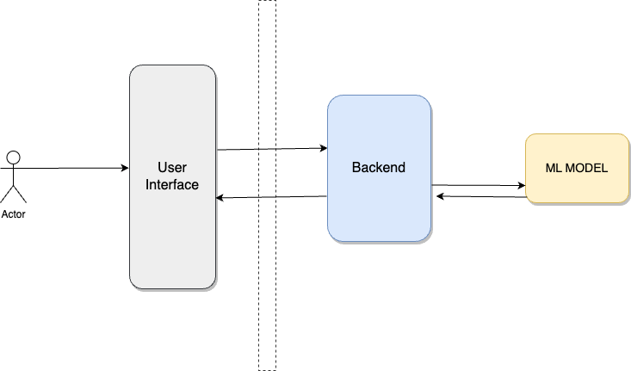

**Experiment and Results:**

# **Phase 1: Business Understanding**

Our objective is to develop a system that, given the total time and translated ingredients, recommends a recipe that is closest to these criteria. This can be viewed as a recommendation system problem where the input features are time and ingredients, and the output is a recipe recommendation.

# **Phase 2: Data Understanding**

Started by loading the dataset and performed an initial analysis to understand its structure, content, and quality. This will include looking at the number of records, features, any missing values, and the types of data we are dealing with.

We did EDA using Sweetviz  
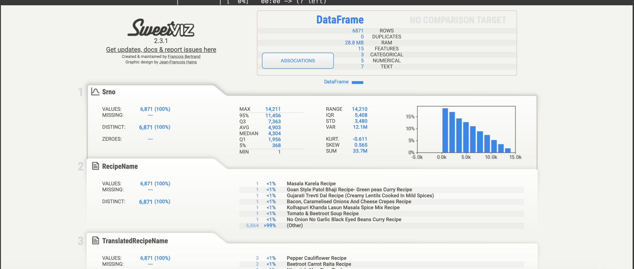

# **Phase 3: Data Preparation**

This phase involves preparing the dataset for modeling. Since our goal is to recommend a recipe based on total time and translated ingredients, we will focus on these aspects.

In this phase we have handled missing values followed by feature engineering and feature selection.

We split the data after that.



# **Phase 4: Modeling**

We will create functions to:

Train Models: Train different regression models.

Inference: Predict using the models.

Evaluation: Use various metrics to evaluate model performance.

Saving Models: Save each trained model and its vectorizer.



**Evaluation**

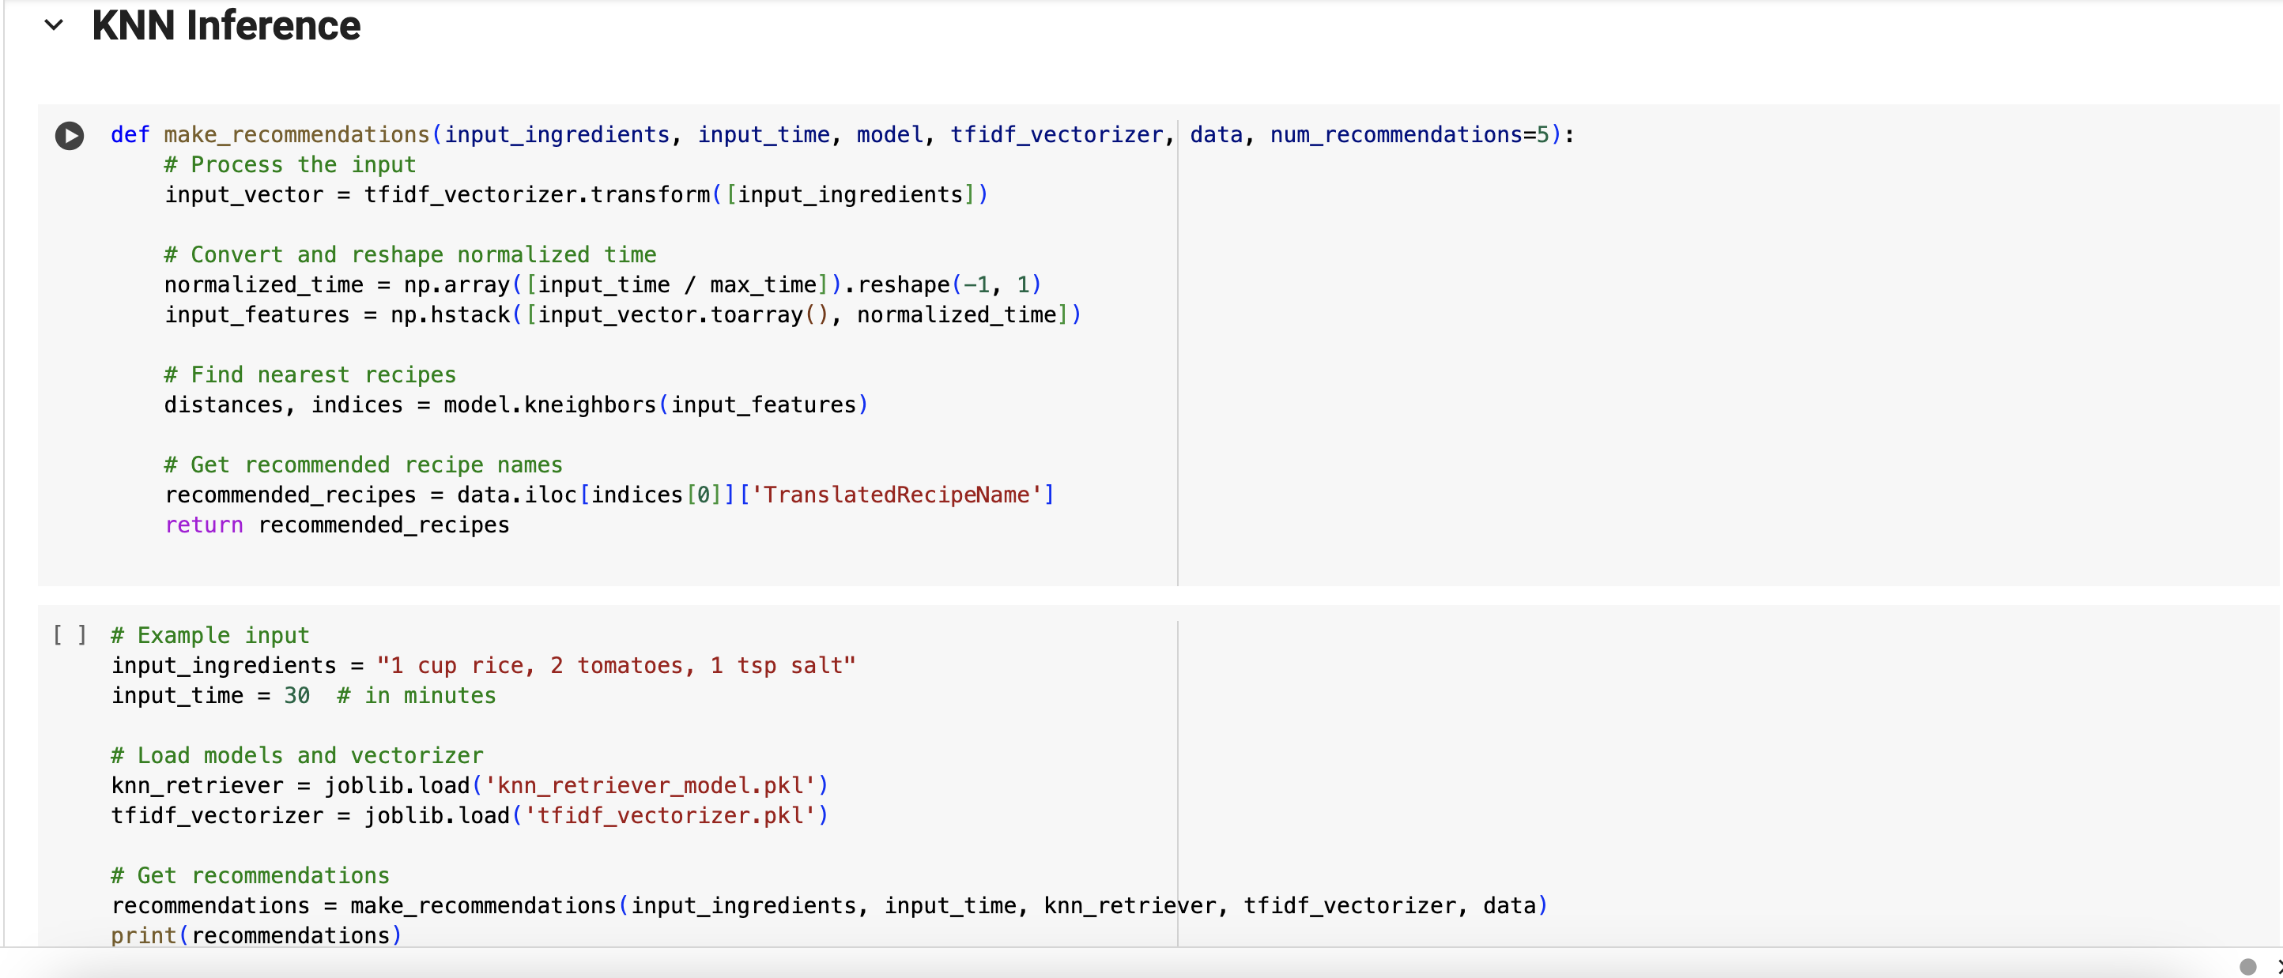

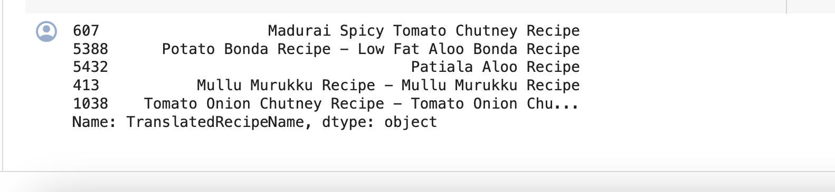

# **KNN All** **possible Metrics!!**

Precision@k: The proportion of recommended items in the top-k set that are relevant.

Recall@k: The proportion of relevant items found in the top-k recommendations.

F1 Score@k: The harmonic means of precision and recall at k.

Mean Reciprocal Rank (MRR): The average of the reciprocal ranks of the first relevant recommendation.

Coverage: The proportion of items in the dataset for which the recommender can provide recommendations.



# **Data Loading, Cleaning, Tokenization**

# **KMeans Training**

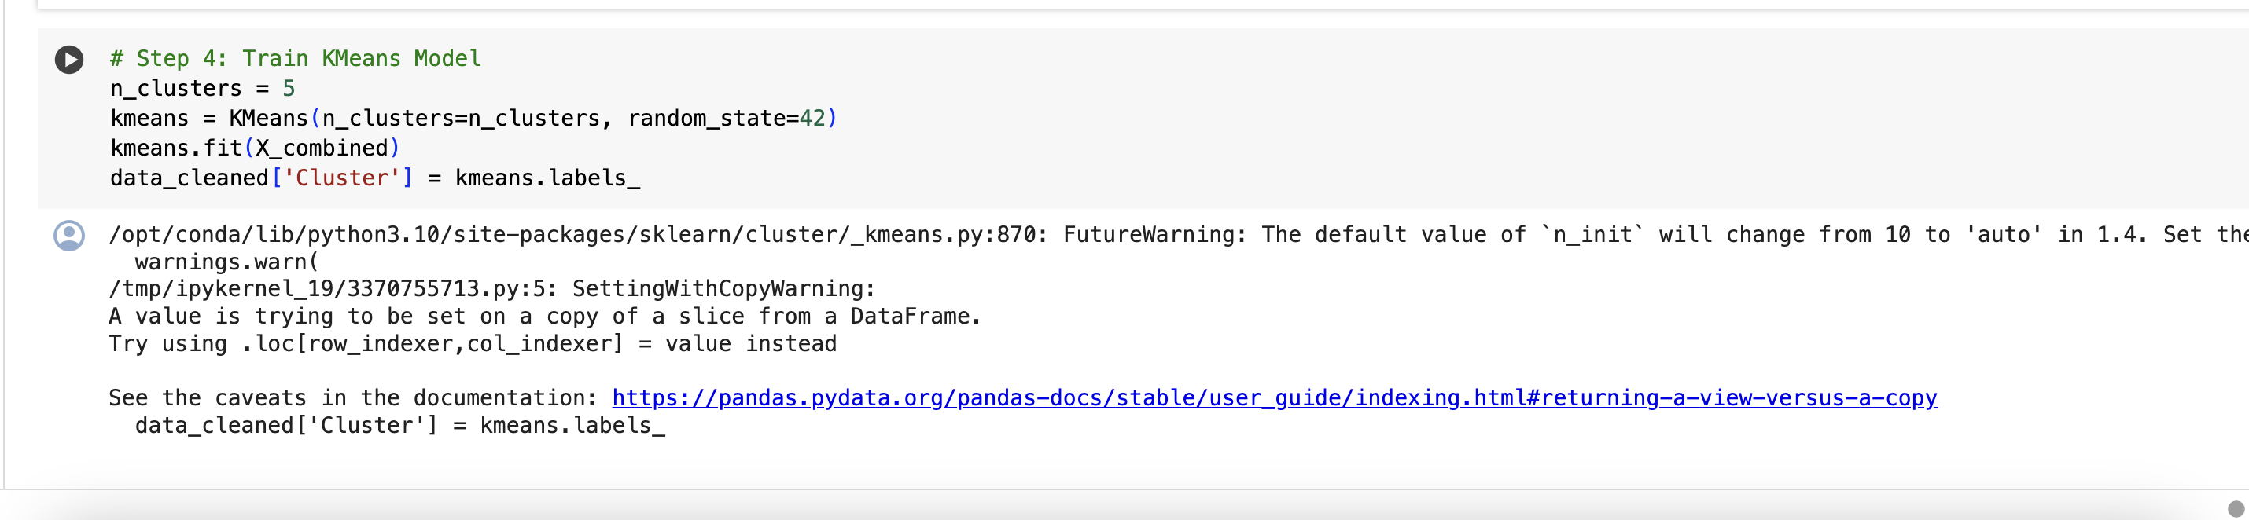

# **KMeans Inference**

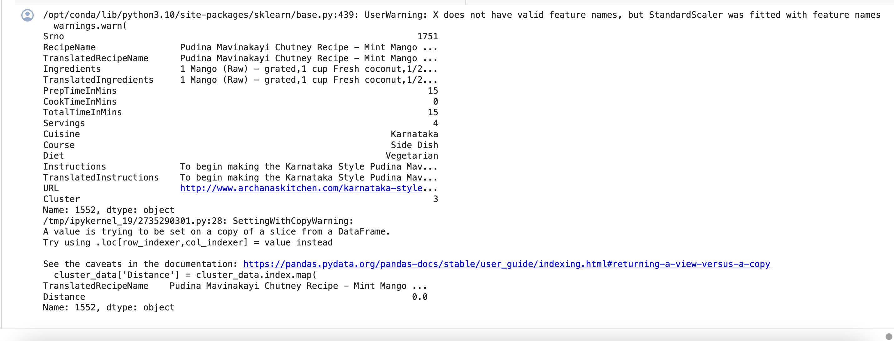

# **KMeans Cluster Visualization and cluster metrics**

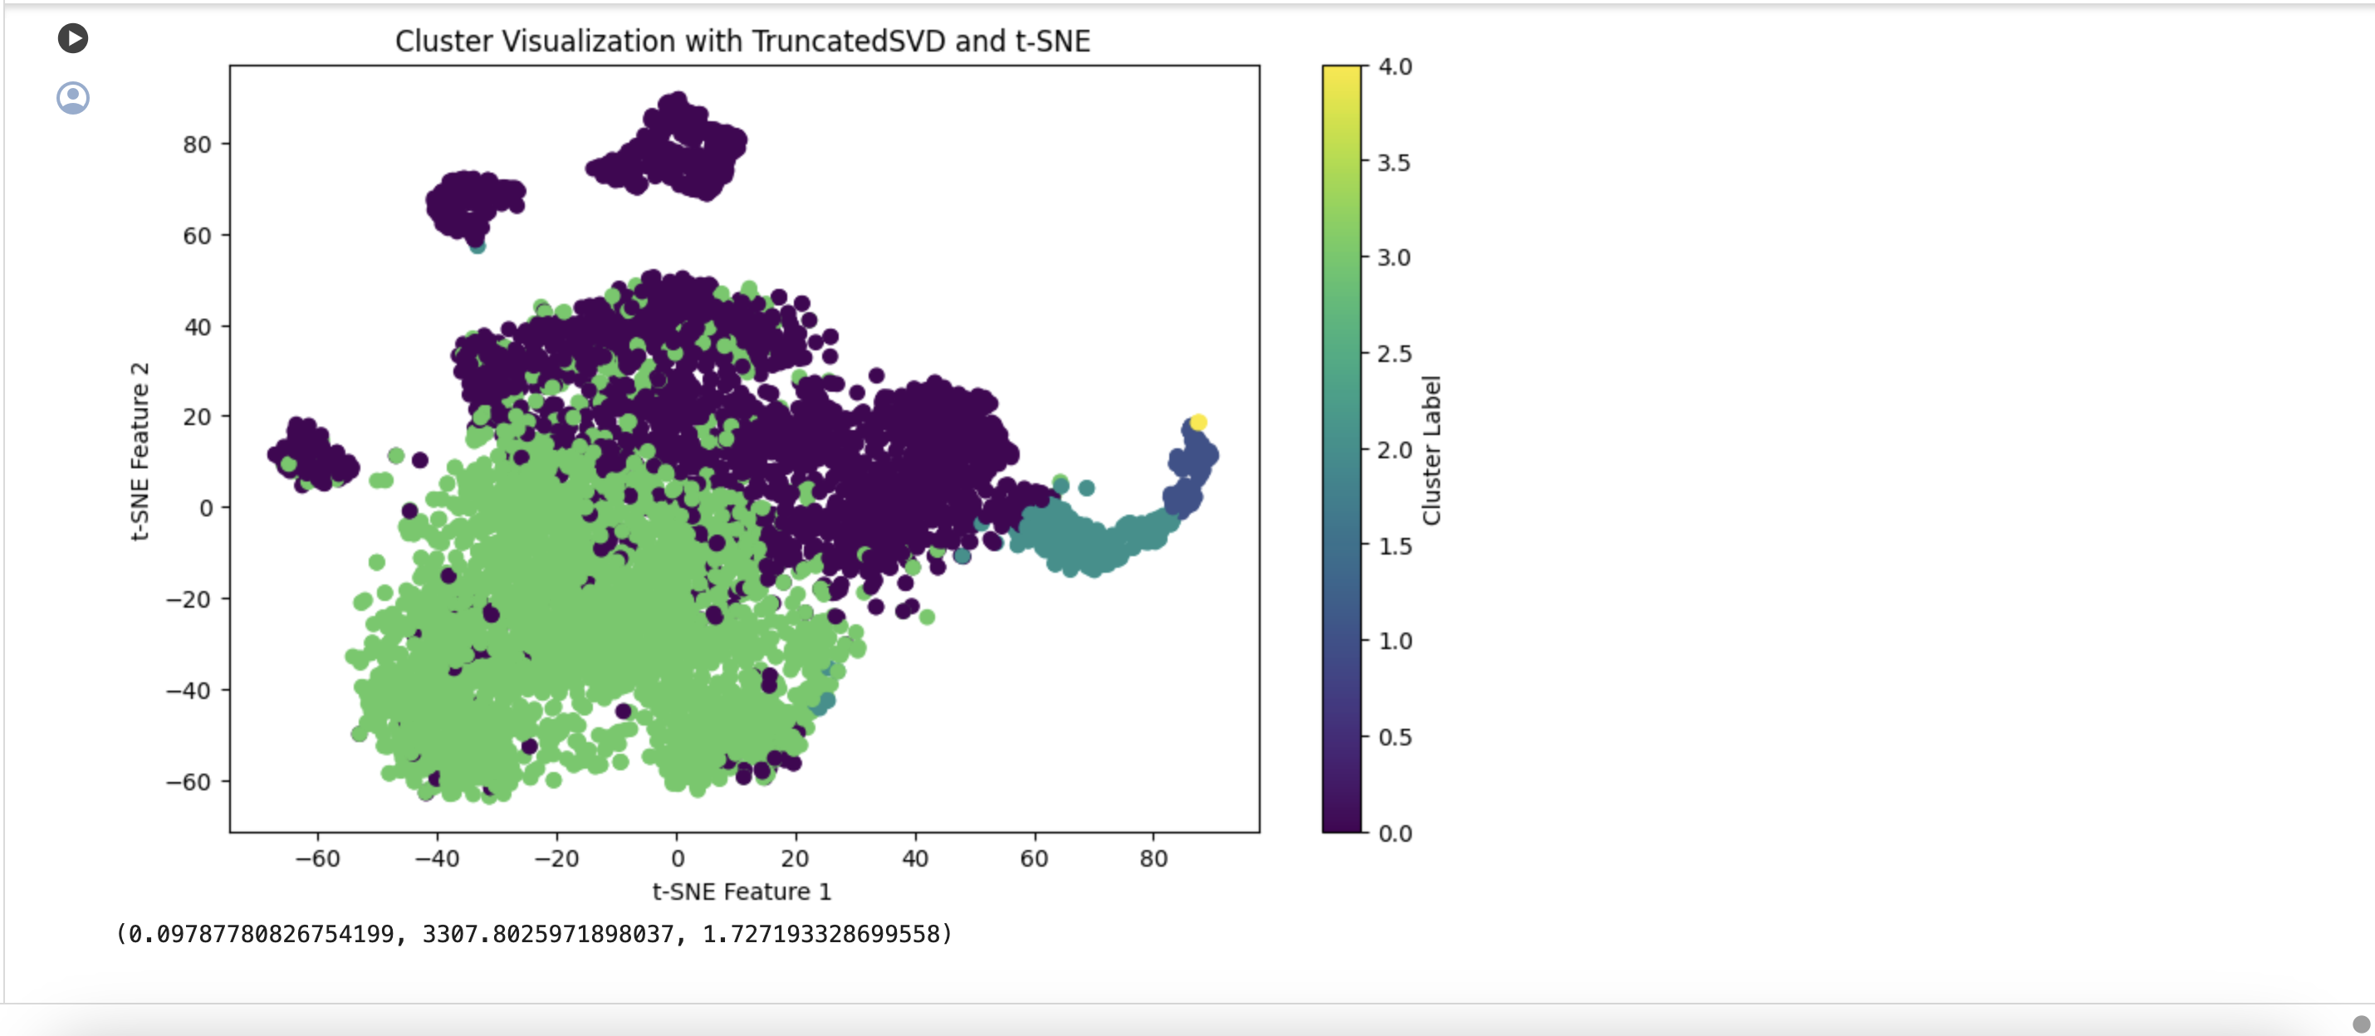

# **All Possible Task Metrics:**

(0.10450198304965984,  
 0.9978160525203789,  
 0.18918996667461824,  
 9.734318895179761e-07,  
 0.00025874879933965853)

### **Visualizations**

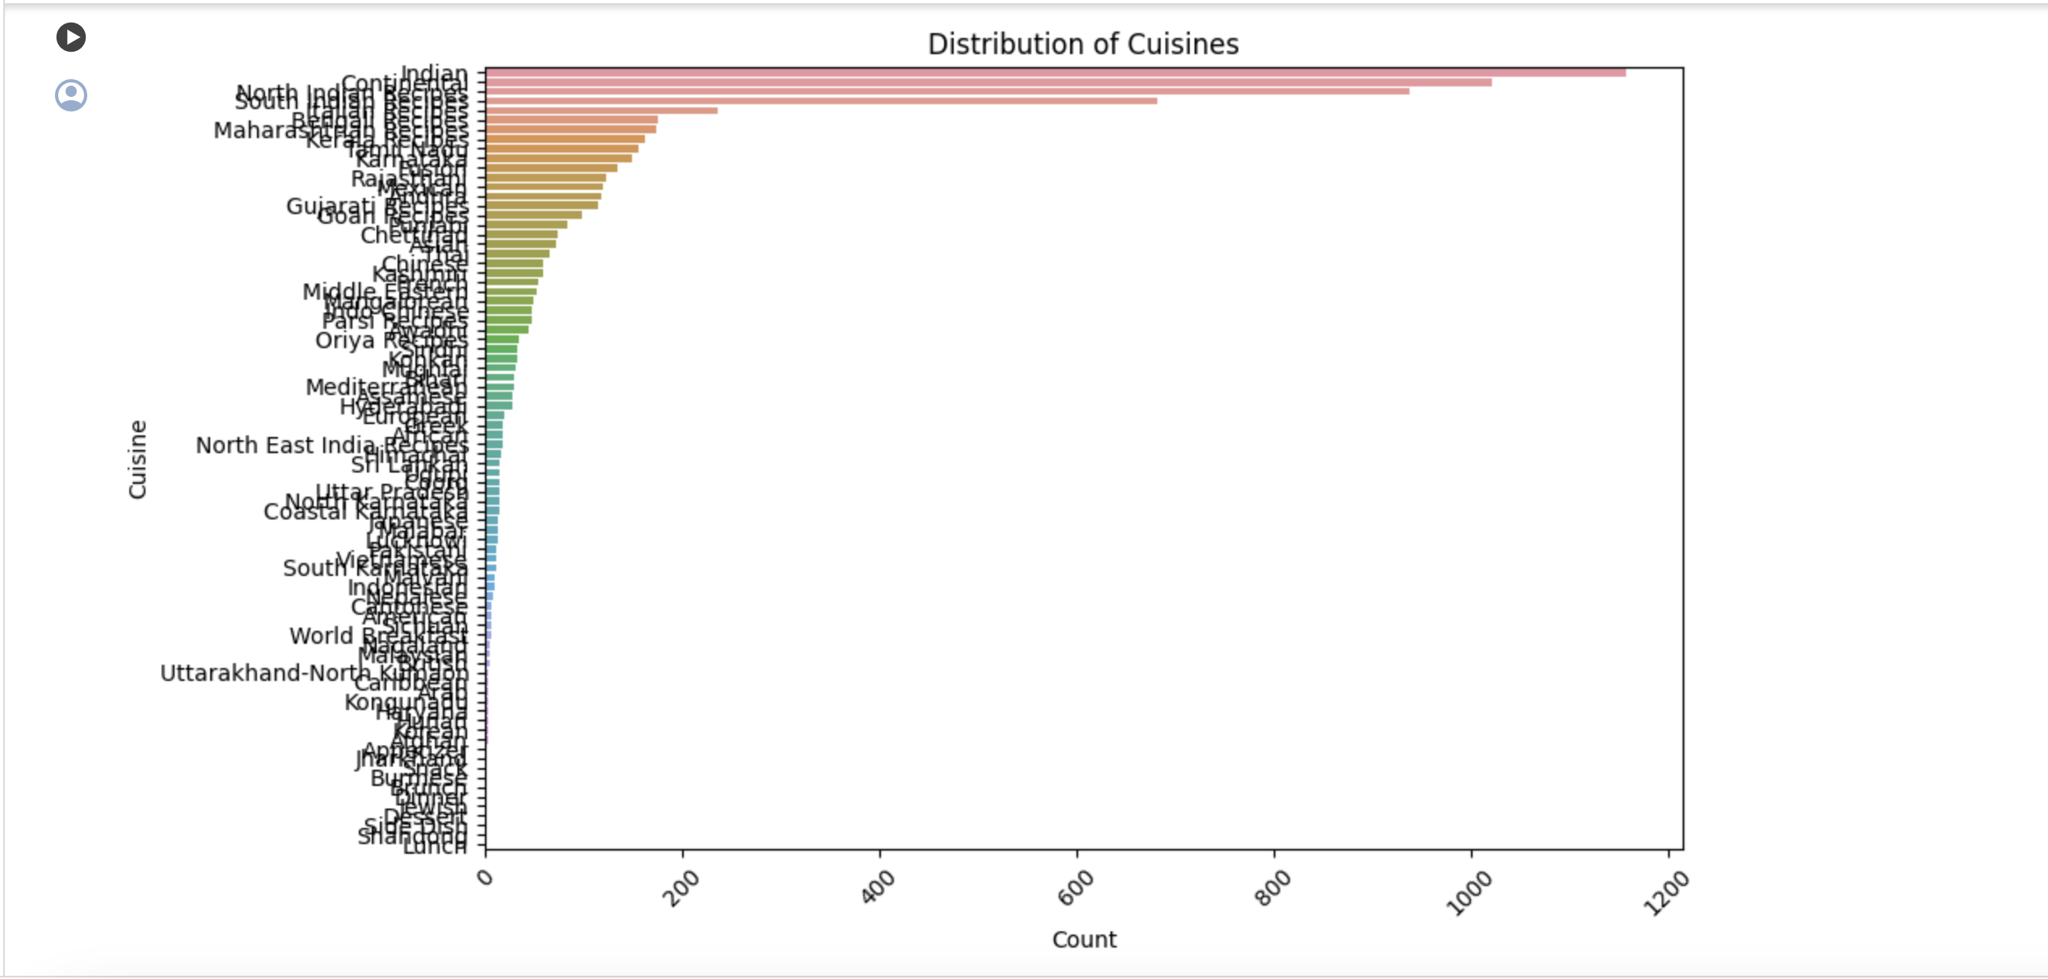

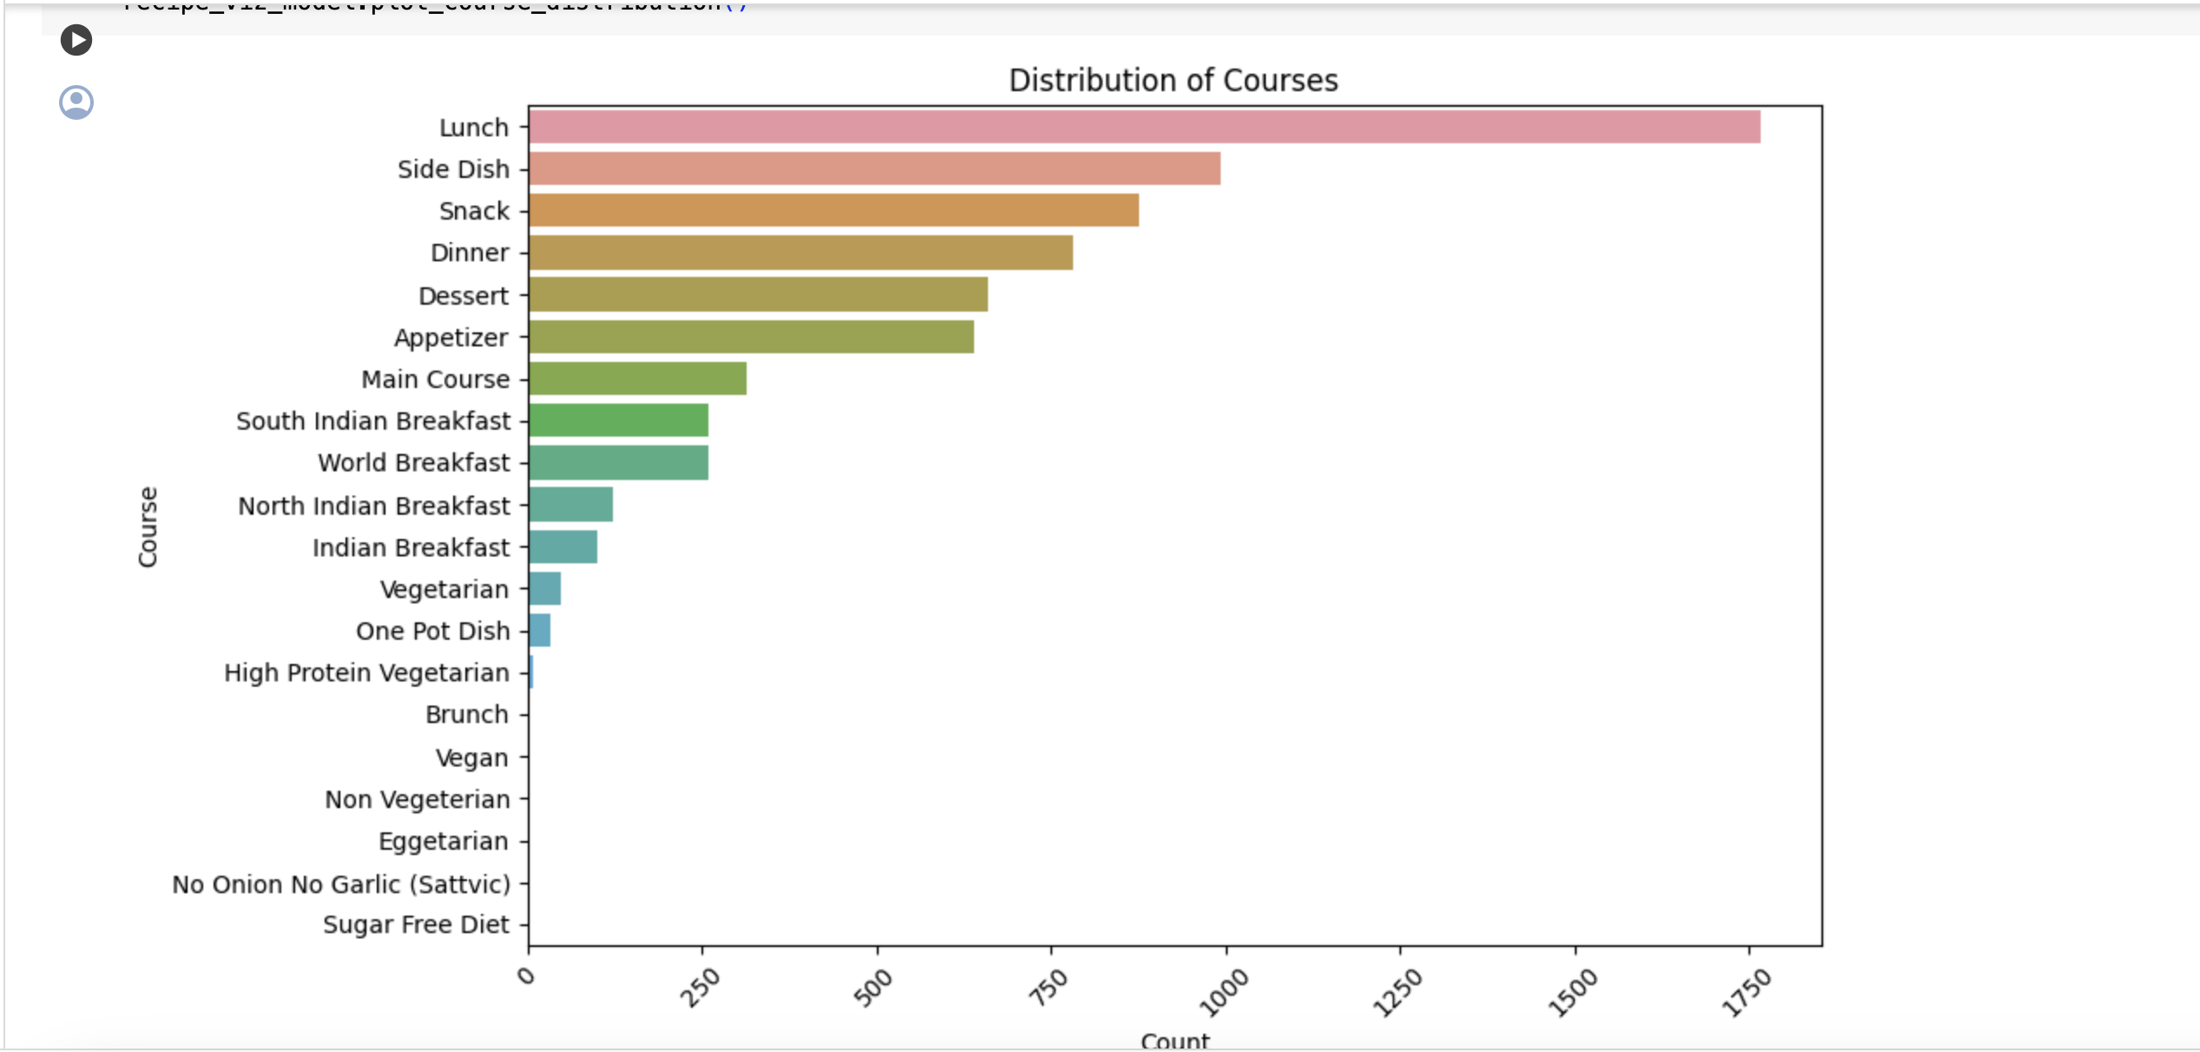

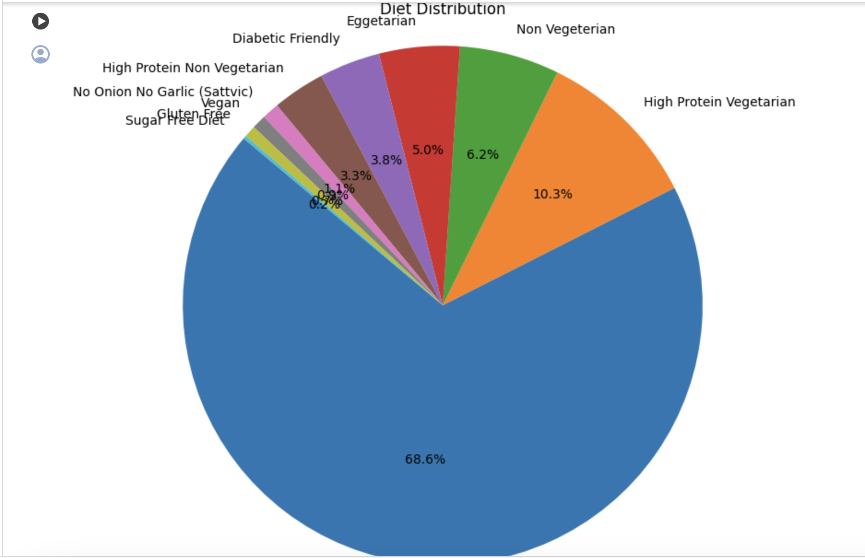

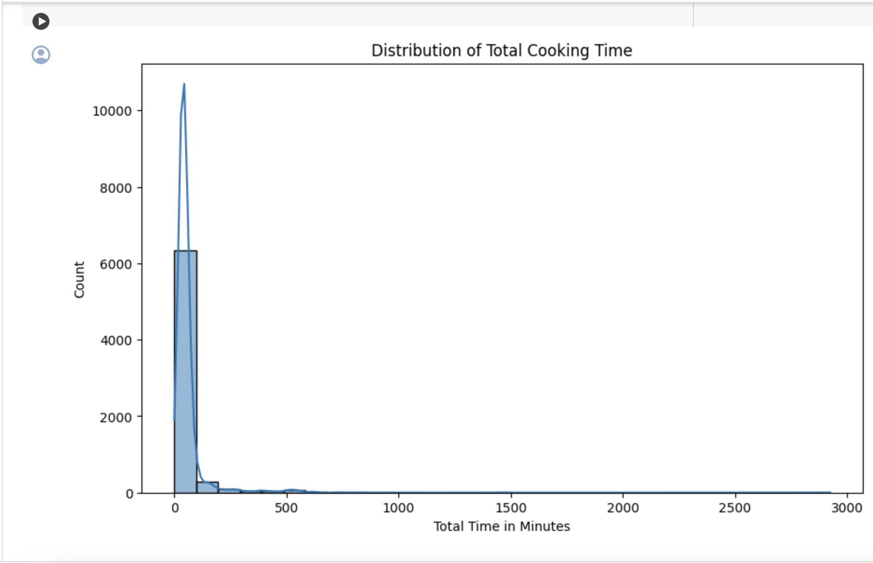

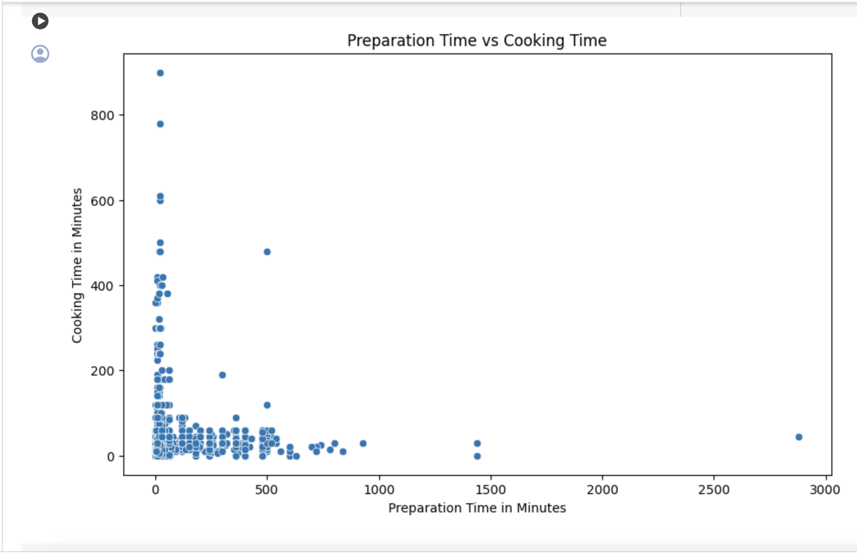

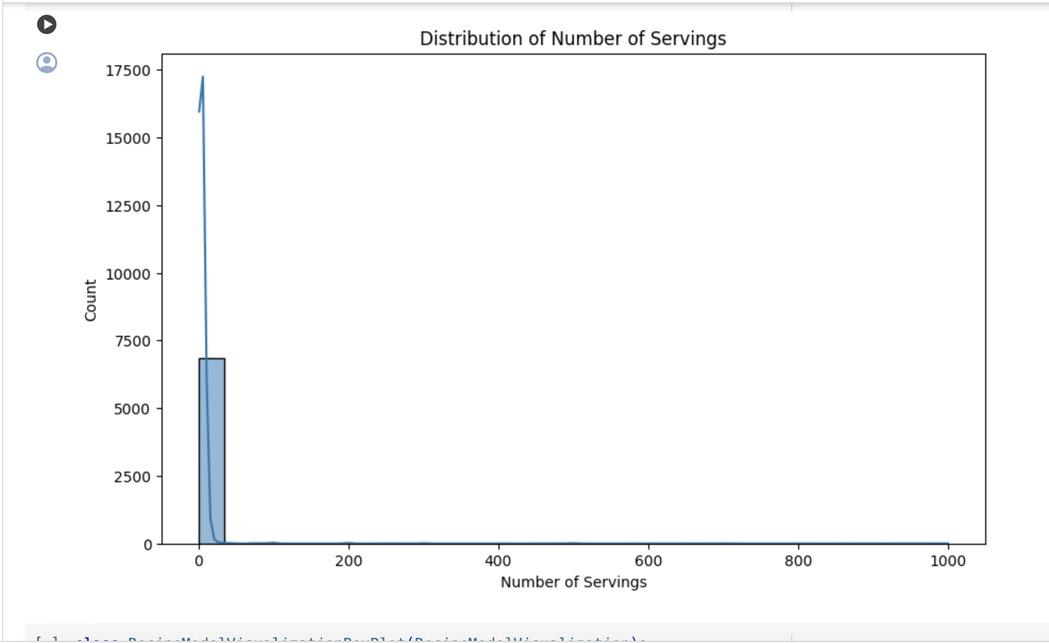

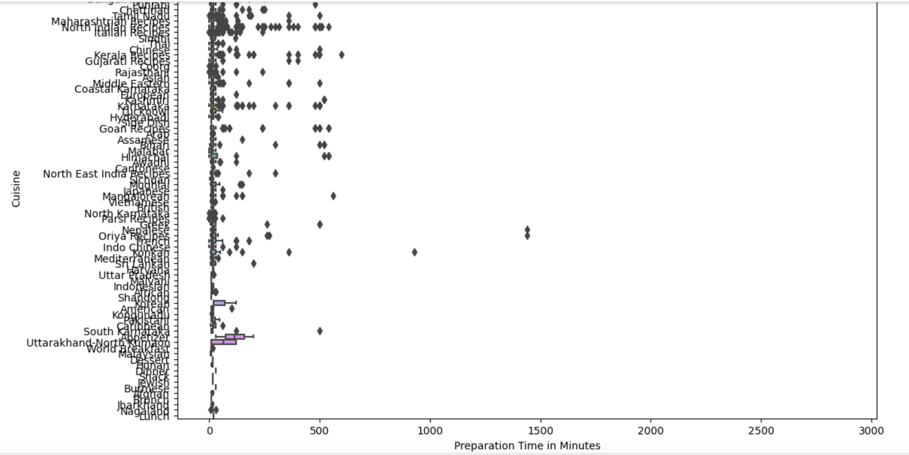

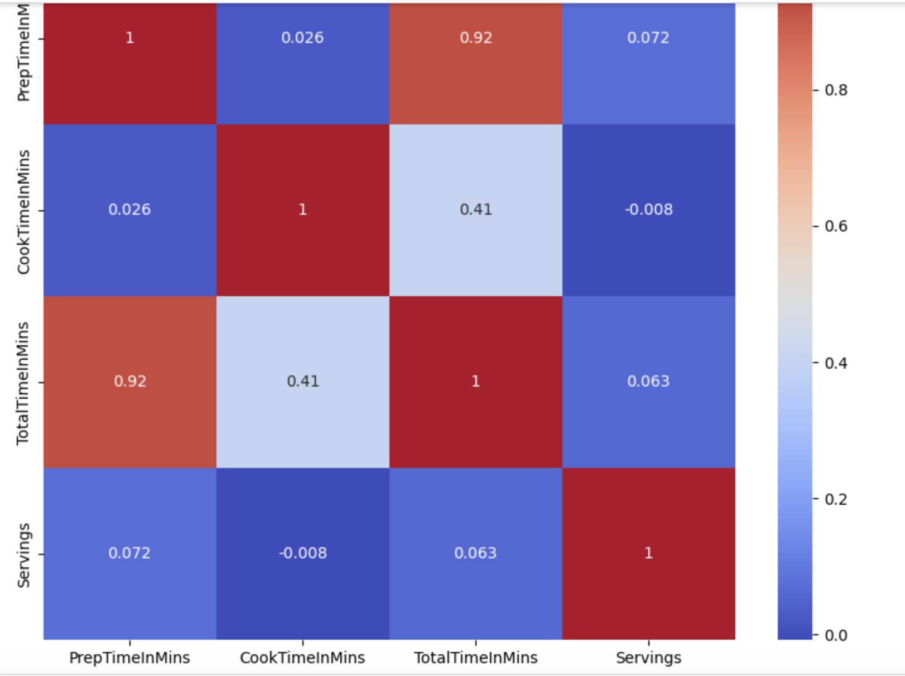

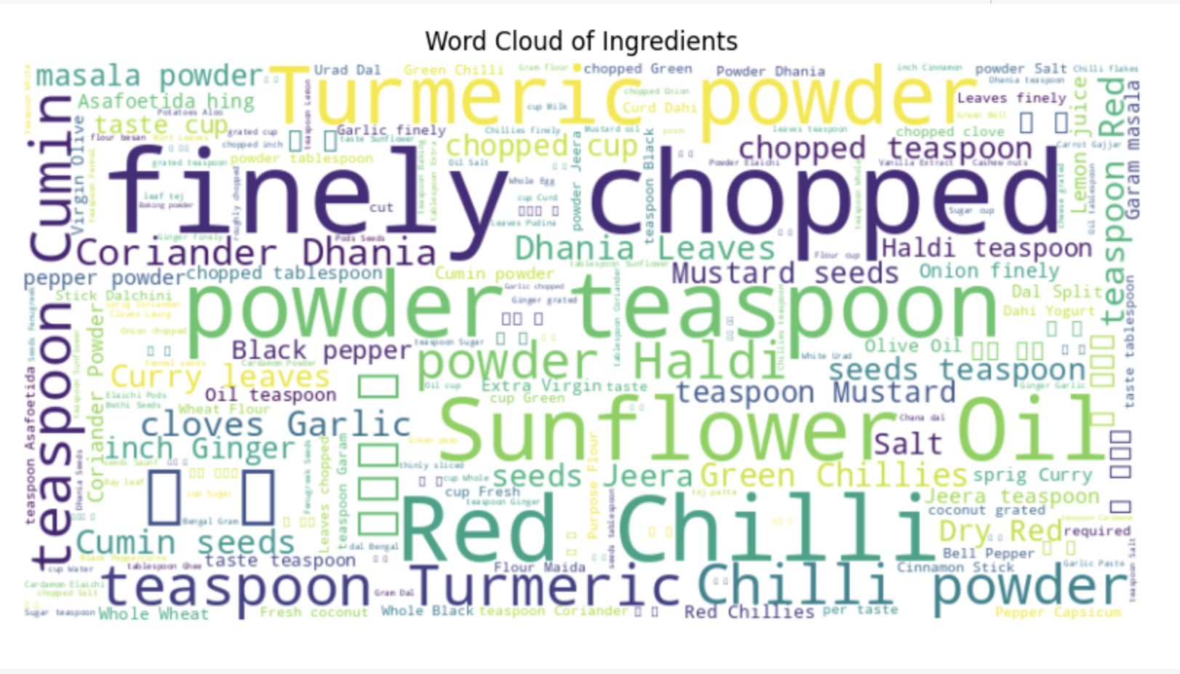

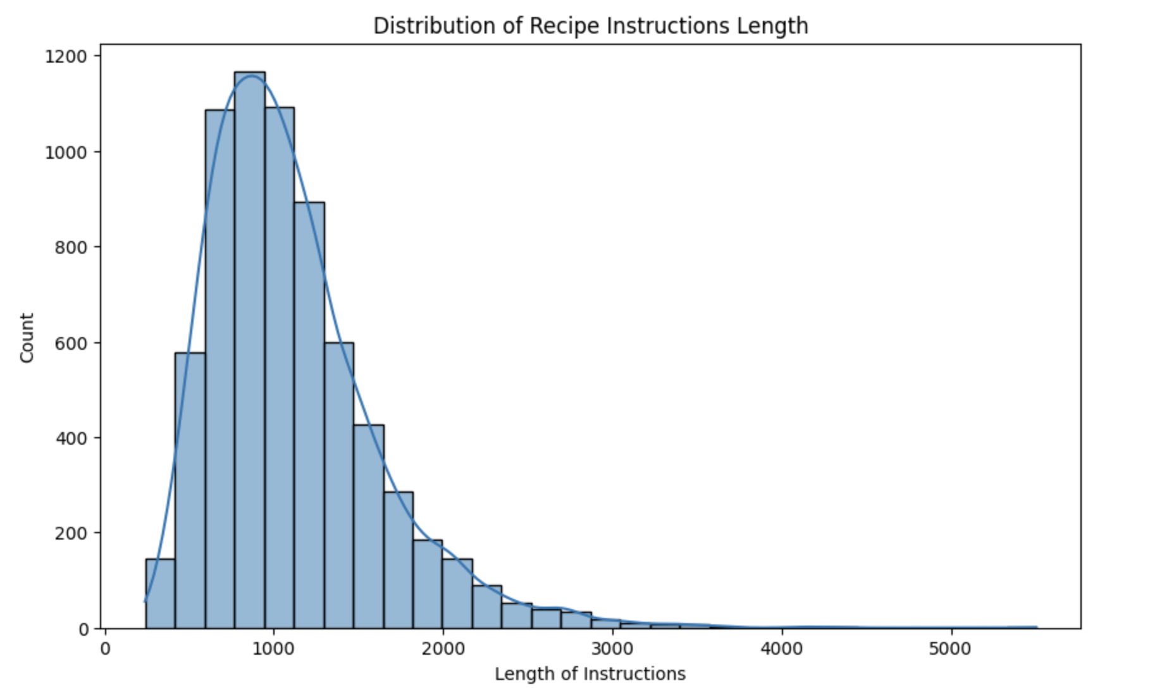

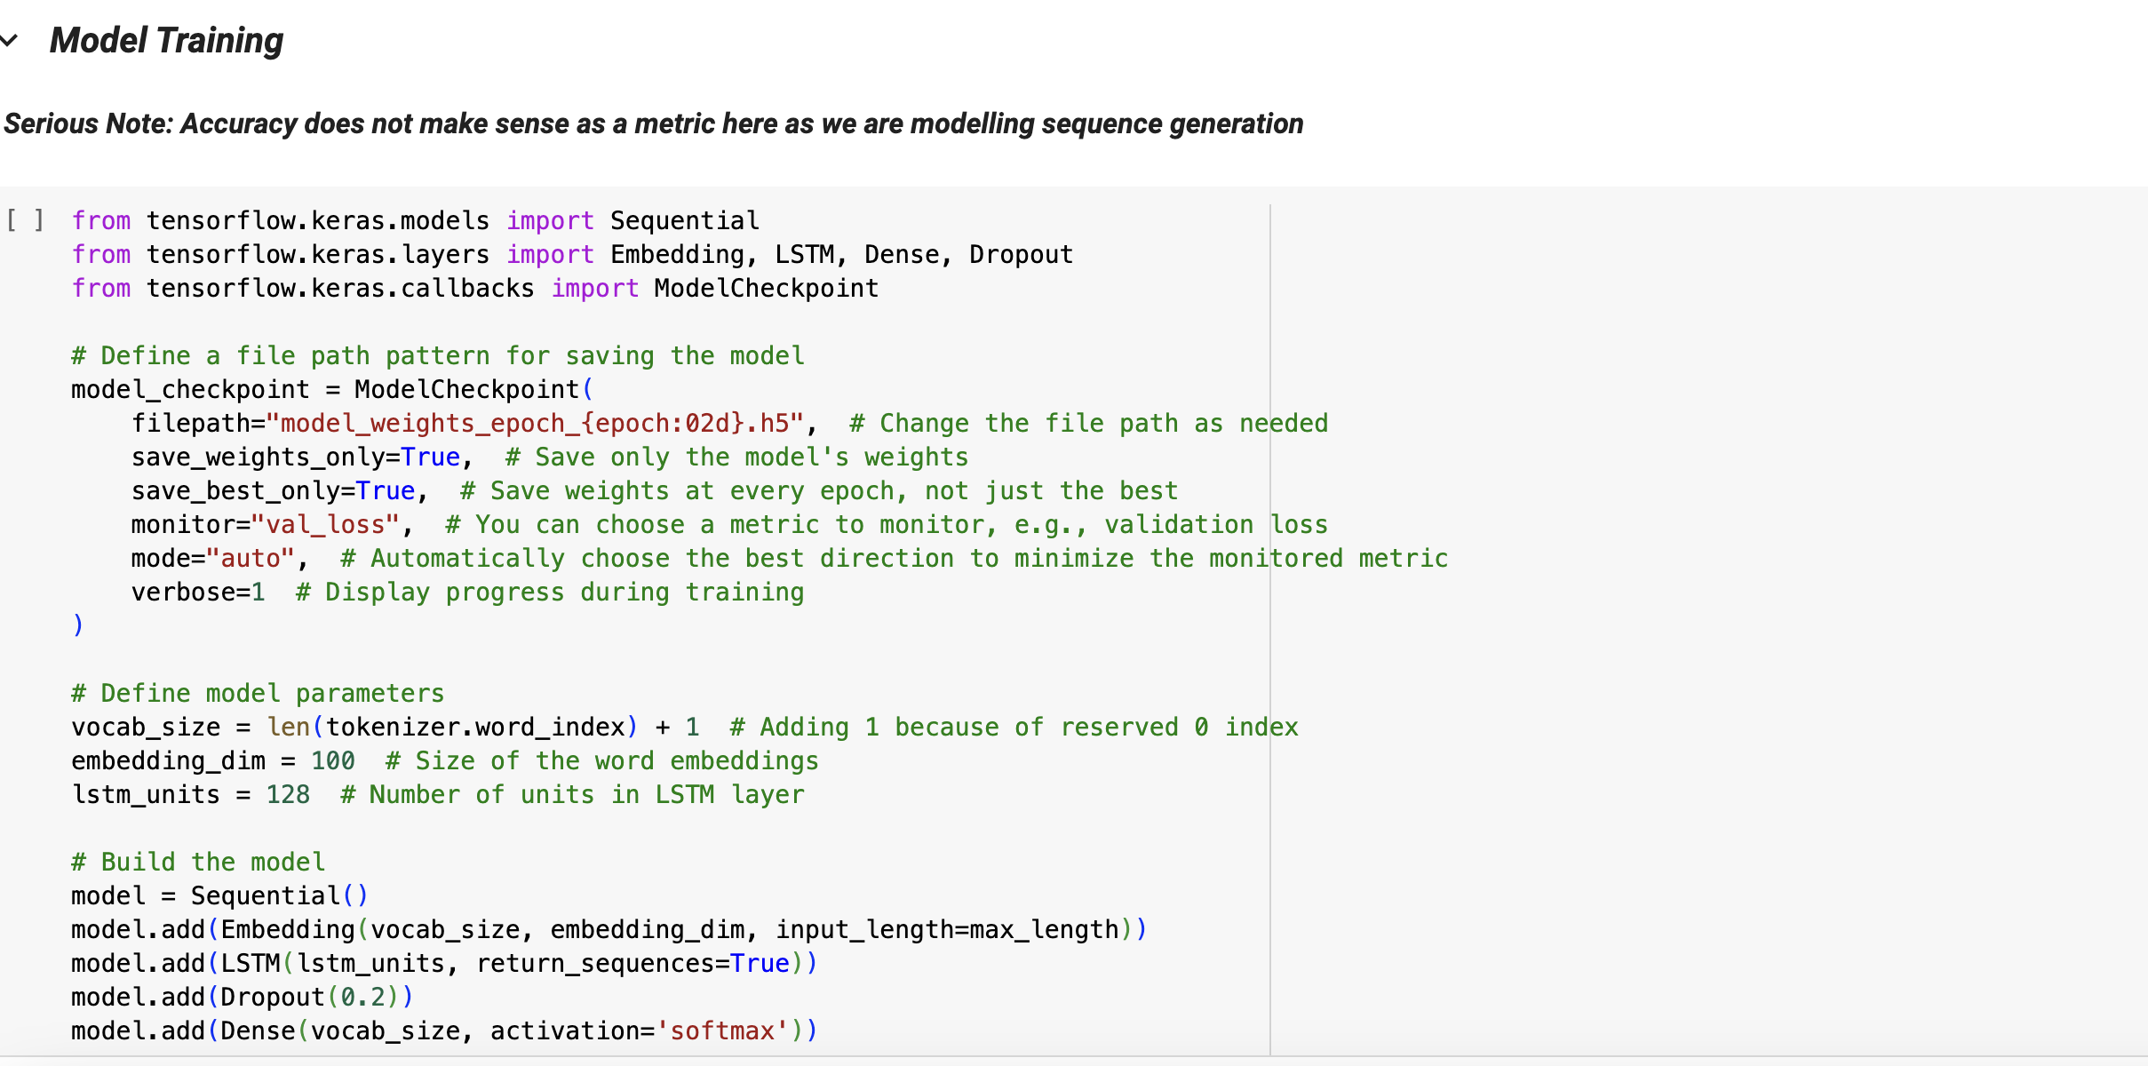

**Tensor board**

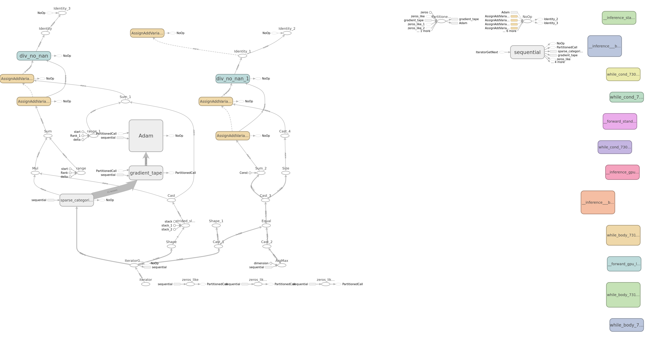

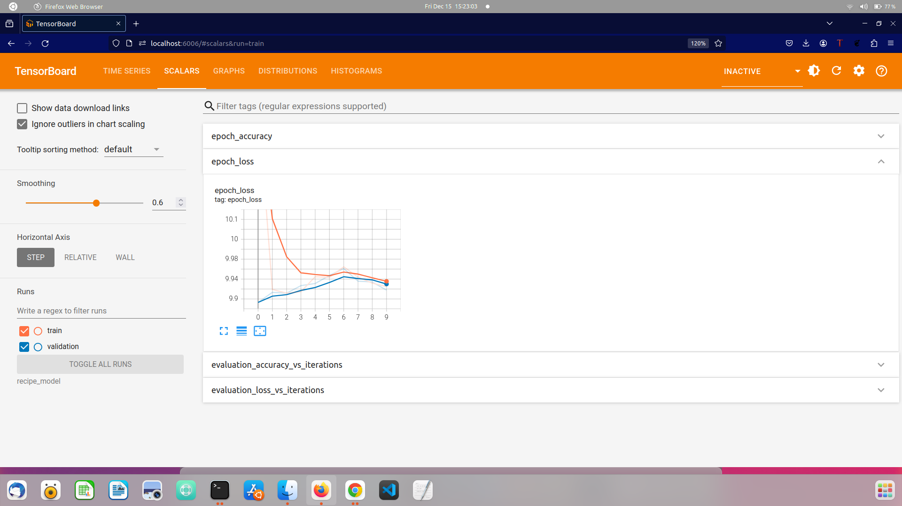

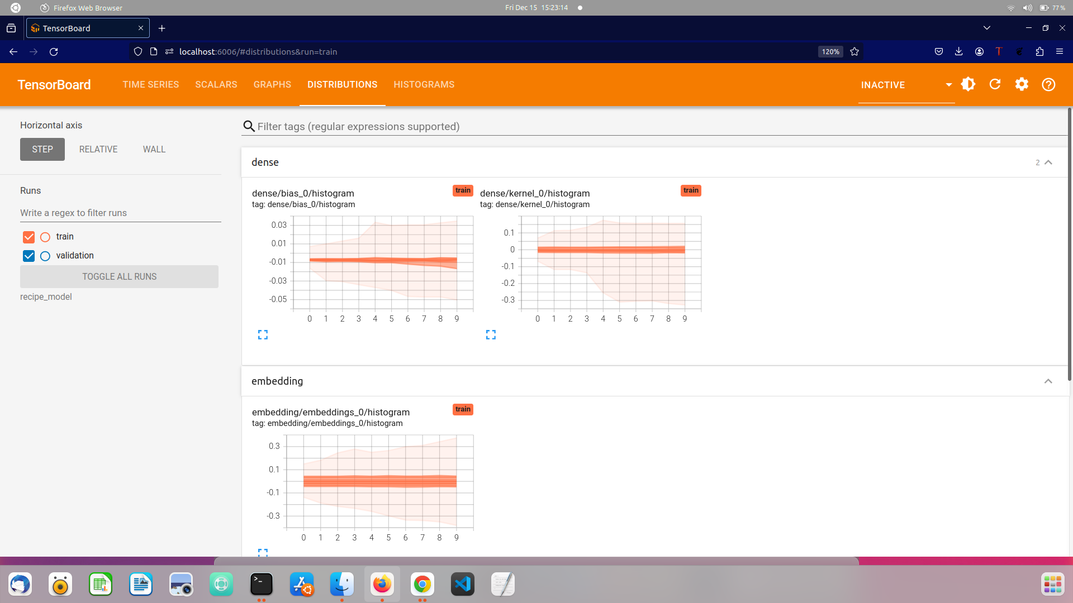

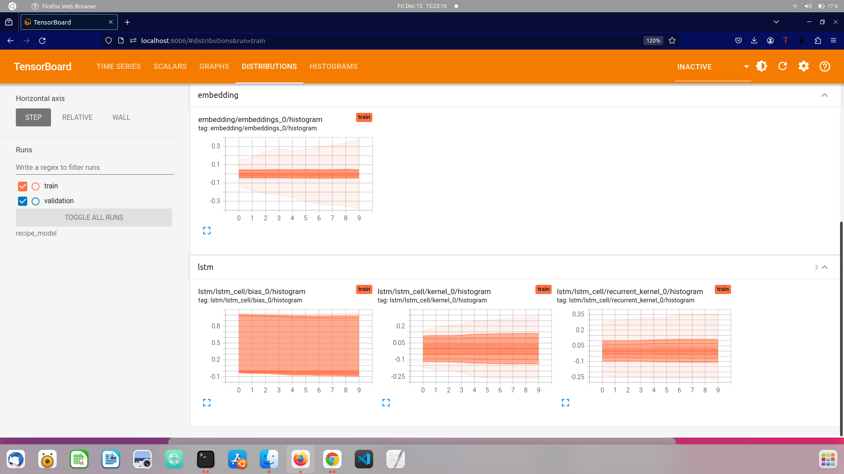

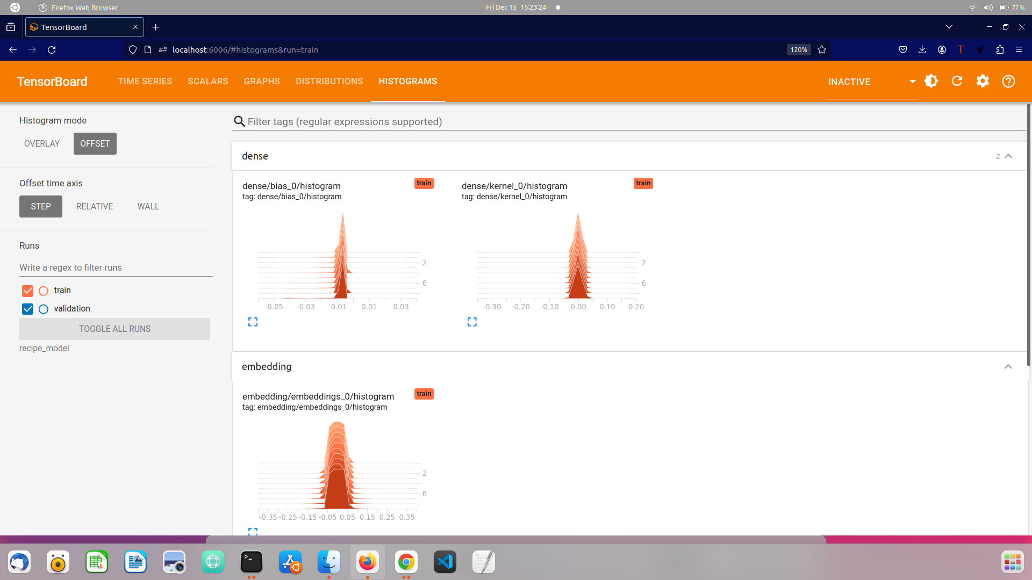

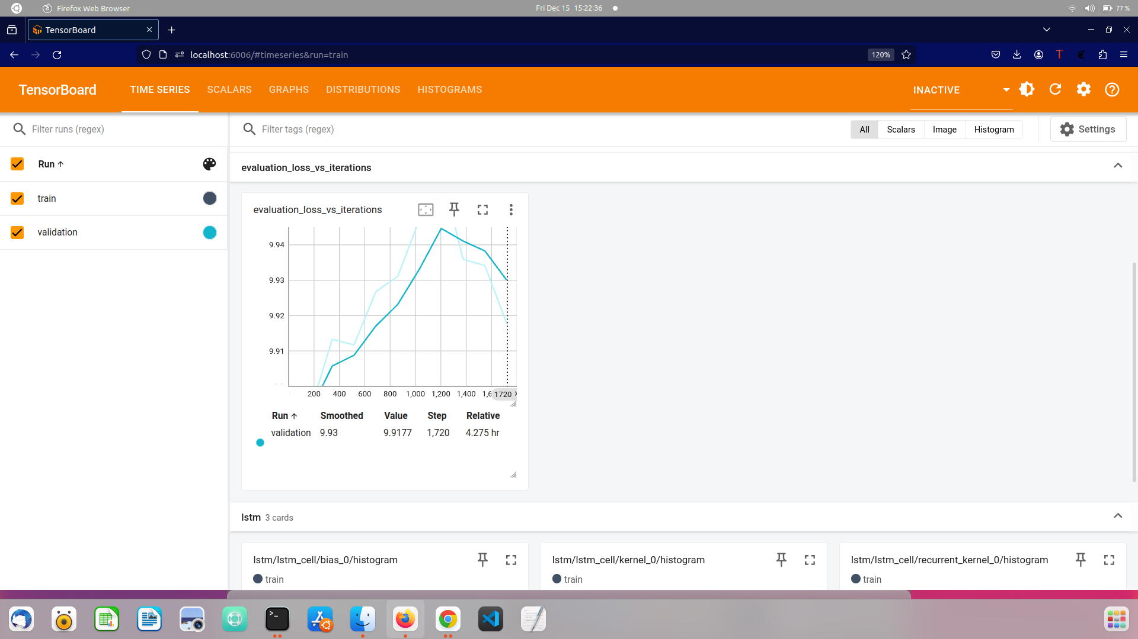

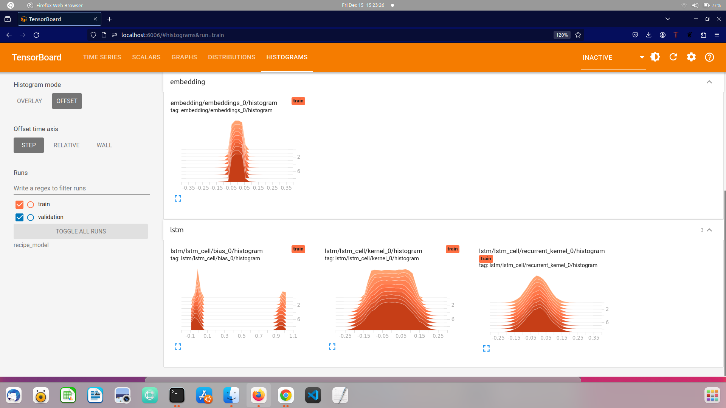

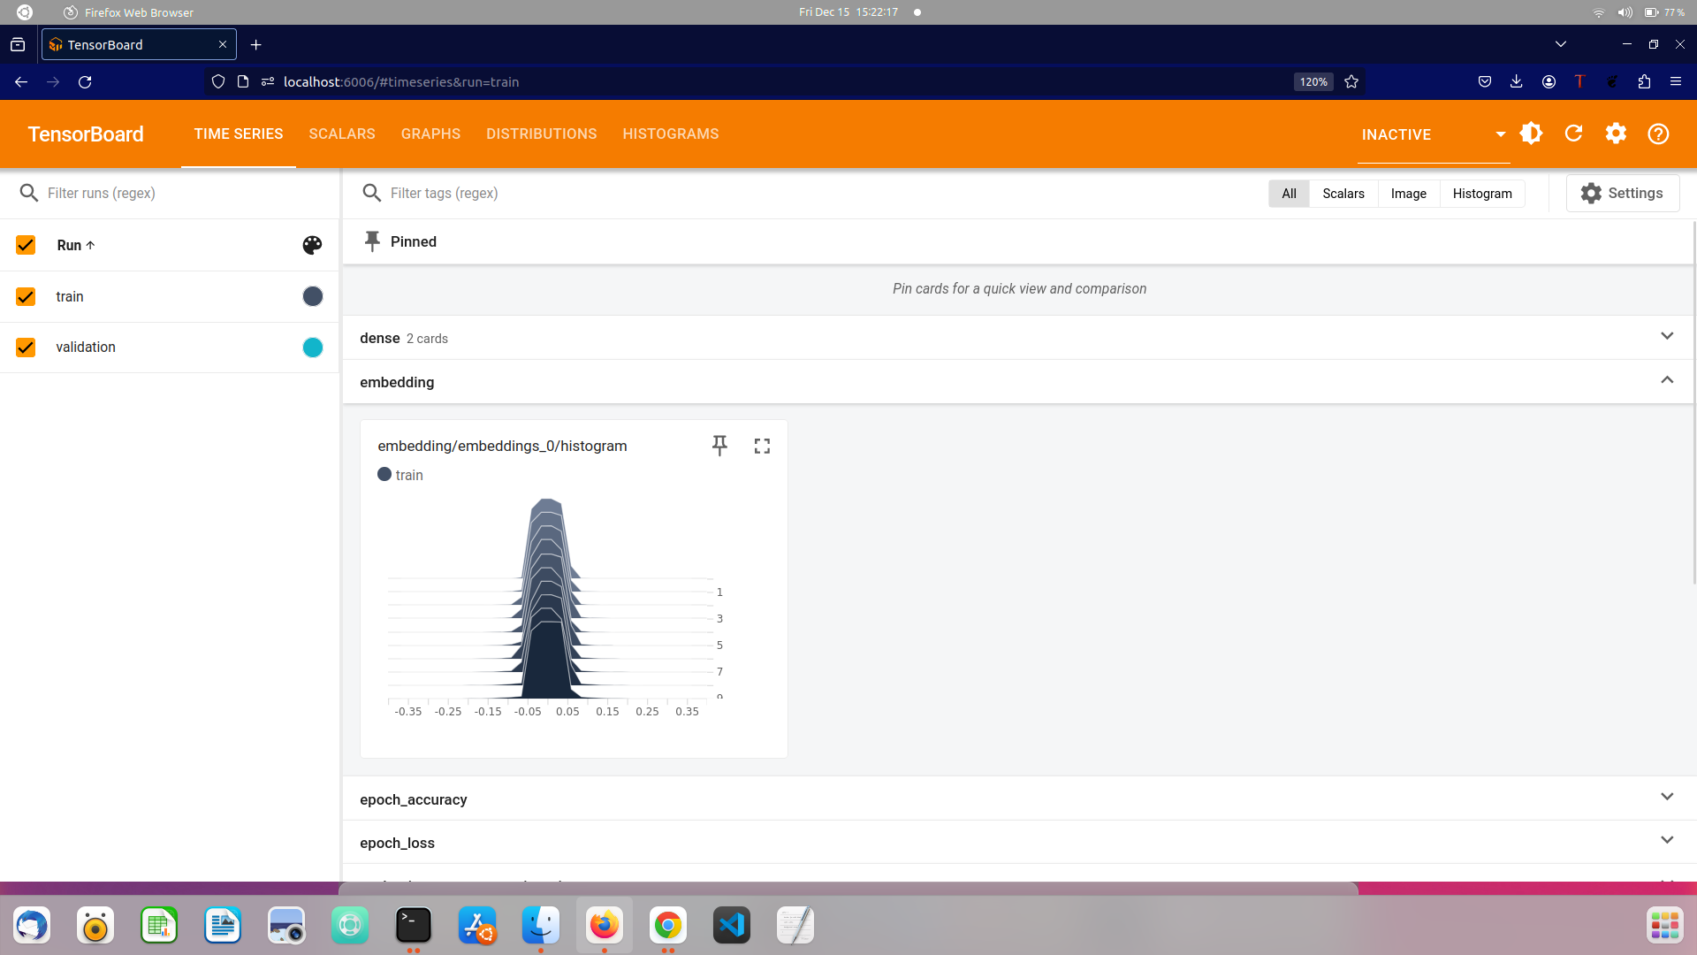

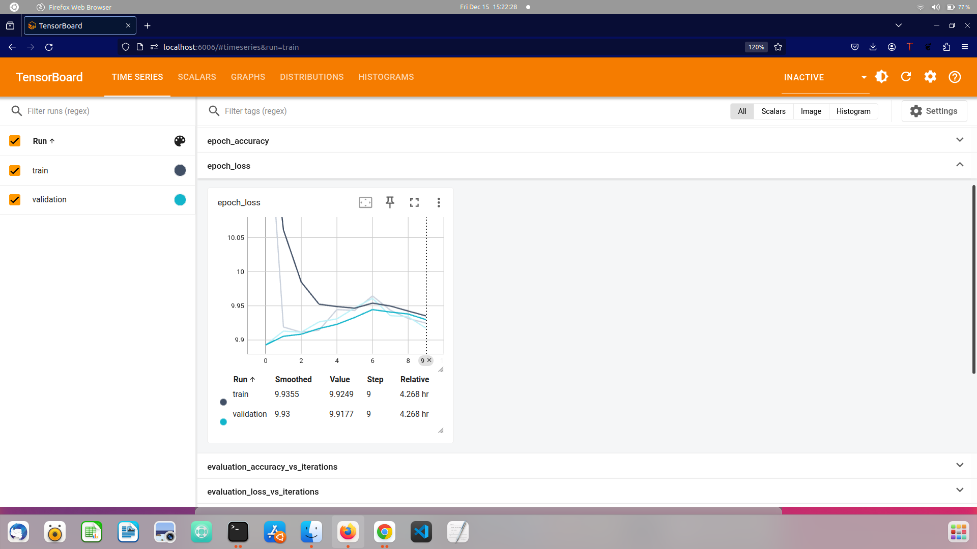

Conclusion:

We concluded that we were able to create a Food meal Recommendation System that is a user-friendly application that enhances the cooking experience and assists users in effectively preparing excellent meals by solving the problem that existed.